Railway trespassing detection and alert system using Deep learning, CNN, YOLO
Karthik Arumugam¹, Harsh Ingle², Yogesh Rajgure³
¹Student, D.Y. Patil Institute of Engineering & Technology, Maharashtra, India
²Student, D.Y. Patil Institute of Engineering & Technology, Maharashtra, India
³Student, D.Y. Patil Institute of Engineering & Technology, Maharashtra, India
---------------------------------------------------------------------***---------------------------------------------------------------------

Abstract - Railroad trespassing and deaths related to it are becoming inevitable due to negligence by people. Such acts pose great safety and security concerns. However, regular monitoring on such sites is not feasible since it requires a lot human labour and also the high resource required and costs corresponding to it are very high. This issue raises an alarm for human safety and thereby laying the foundation of an automated trespassing detection and an alert system to leverage the state of art security system in today's world.
For overcoming this challenge and deploying a security system, we propose a newfangled framework for Live trespassing detection and alert system on railroads. The brain ideation of our system uses a CNN based Deep Learning architecture capable of processing a video and detecting any trespassing activity.
These deep learning-based systems are both good and bad. Such intelligent system on hand proves to be extremely efficient in avoid such dangerous activity but on other hand are time consuming along with being computationally very expensive while dealing with loads of video data.
To overcome this hurdle, our proposed solution involves a multi stage approach that uses Deep learning architecture, composed of an inexpensive trespassing detection, followed by a robust and accurate trespassing classification using the deep neural networks. The resulting solution overcomes the issue discussed above and is flexible in terms of trading the accuracy with the time required for the computations.

Key Words: Railway Trespassing detection, Railroad safety, Deep learning, Video surveillance, Deep Convolutional Neural Networks, Background subtraction, Computer vision, You Only Look Once.

1.INTRODUCTION

An interesting and yet one of the disturbing facts of this century has been related to railway security. In the last decade and till mid-2015, over 2700 deaths and more than 10000 injuries related to railway trespassing have been reported. This has further worsened with the ministry of railways reporting nearly 29,000-30,000 deaths in past 3 years. According to reports over 50% of railway crossings are exposed to potentially dangerous activities. Such sites pose a great threat to loss of life. In most cases, collision with a train happens to be a reason of death of the trespasser.
In such scenarios human supervision become challenging provided the scale at which the deaths are happening. Due to this, deploying an automated artificial intelligence tool becomes vital. Trespassing detection serves as the foundation in any automated AI-driven trespassing detection and alert solution. An automated trespassing detection system would not only provide reliable detection in a timely manner but will also allow us to do advanced analytics for trespassing in future.

1.1 Motivation

Being responsible and having awareness about the rules to be followed at the railway station are the things we lack. In order to save a few minutes or seconds people are willing to put their life on the line. Following necessary precaution is extremely important but at the same time it is hard to expect everyone to abide by the rules.
To overcome the above challenge attempts have been made by researchers and governments to build a reliable solution to detect trespassing on rail tracks. Such attempts have been proven to decrease fatality rate and thereby forming the foundation of our project to build a robust trespassing detection and alert system.
1.2 Problem Statement

The railways being a huge network connecting different parts of the country also causes exposure of the tracks and aids in human trespassing causing a lot of deaths. A large number of crowds makes it difficult to identify and separate those from trespassing and those following the rules.
In 2019, Muzammil Bashir, Elike A. Rundensteiner and Ramoza Ahsan came with their research paper titled "A deep learning approach to trespassing detection using video surveillance data"[1]. In this paper they have researched and demonstrated trespassing monitoring using video surveillance footage. The architecture they designed gives an intuition to solve the problem.
Keeping in mind the approaches made previously we further propose a system that is capable to detecting trespassing activity on railway tracks using video

surveillance data and sending an alert in form of alarm or notification along with the location where the trespassing has happened. This solution will help in drastically reducing the deaths caused by human trespassing.

2. LITERATURE SURVEY

Sr. No. | Title | Authors | Year | Description/Approach
1 | A deep learning approach to trespassing detection  using video surveillance data | Muzammil Bashir, Elke A. Rundensteiner, Ramoza Ahsan | 2019 | In this paper the researchers have developed their automated framework called ARTS - Automated railroad trespassing detection system.  This system uses a 2 stage approach based on CNN to solve the trespassing detection.
2 | A deep learning approach towards railway safety risk assessment | Hamad Alawad , Sakdirat Kaewunruen , Min An | 2020 | It proposes an effective Realtime risk management solution based on CNN to improve safety throughout the entire railway industry by preventing fatal accidents.
3 | YOLO Based Real-Time Human Detection for Smart Video Surveillance at the Edge | Huy Hoang Nguyen,  Thi Nhung Ta, Ngoc Cuong Nguyen, Van Truong Bui,  Hung Manh Pham,  Duc Minh Nguyen | 2021 | This paper proposes an approach based on YOLOv2 for human detection. This approach utilizes combined benefits of YOLO residual blocks and multiple spatial pyramid pooling blocks. The proposed model shows high accuracy across various datasets.
4 | Analysis of Deep Learning Architectures for Object  Detection - A Critical Review | Mohit Pandiya, Sayonee Dassani, Dr. Mangalraj P | 2020 | This paper proposes a solution having 4 different architectures for comparative analysis and explains the optimality and compatibility.
5 | Video Abnormal Event Detection Based on CNN and LSTM | Guangli Wu*, Zhenzhou Guo, Leiting Li, Chengxiang Wang | 2020 | In this paper, CNN combined with LSTM of  convolutional neural network was used to build the model of  abnormal event detection in video. UCSD and UMN dataset to carry  out the experiment of abnormal event detection and analysis  in video, and achieved certain good results.

3. PROPOSED WORK

Our proposed system solves the problem of trespassing with a multistage automated approach. The first stage consists of capturing the live video on railway tracks/station and then will try to remove the frames in which no significant activity will be detected. This will allow to reduce the computation time required to process the data and this will be aided by state of art OpenCV techniques in Python. Each frame of the video will be dissected and processing will done where human motion is captured. The next stage of the solution involves the use of YOLO - deep learning model based on CNN which uses the TensorFlow and Keras libraries at the backend which will be responsible for effective classification to decide whether or not trespassing is happening.
- All of the above process will be happening in all of the cameras placed at the station simultaneously.
- So initially after capturing any kind of motion in the surveillance, the processing will happen in the form of filtering out the frames that have no motion activity and the places where there is any activity happening will be marked as Region of interest (ROI).
- Upon filtering these frames/data will passed to the YOLO model which will then detect the exact coordinates of where the human is in the ROI.
- Once the model has the location, it will then try to calculate if that location falls in safe limits or not and will. The ones within the safe limits and identified as the station worker will be skipped and further withing the ROI the bounding boxes will be used to detect and classify the commoners who are breaching the rules as trespassers and thereby registering a trespassing event and raise an immediate alarm.
All of this information will be stored in the database. And for ones where the alarm is raised the location details/coordinates will be sent to the Railway administration to take further necessary actions.

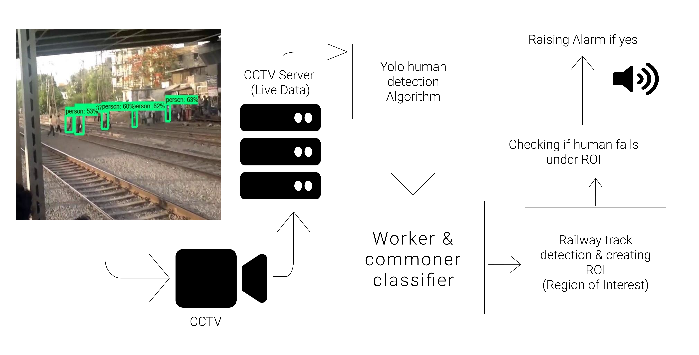
Figure 1 : System Architecture

3.1 YOLO (You Only Look Once)

YOLO You Only Look Once, is a framework that deals with object detection in a different way. The R-CNN family of techniques primarily use regions to localize the objects within the image. The network does not look at the entire image, only at the parts of the images which have a higher chance of containing an object [2].

Yolo on other hand takes the entire image in a single instance and predicts the bounding box coordinates and class probabilities for these boxes. These bounding boxes are weighted with the calculated probabilities [2].

The biggest advantage of using YOLO is its speed it is incredibly fast and can process 45 frames per second. YOLO also understands generalized object representation [2].

Being a part of the class of robust object detection algorithms, YOLO has been a significant leap in this field. Since it looks at the image a whole the predictions are informed by the global context of the image. Also, YOLO is one of the best algorithms for object detection and has shown a comparatively similar and sometimes better performance to the R-CNN and Fast R-CNN algorithms, since it uses single network for predictions unlike R-CNN that need plethora of images[2].

3.2 CNN (Convolutional Neural Network)

To detect if the trespassing is happening or not we feed the images to the CNN.
Given an input surveillance video containing N frames, the model has to predict a binary time series of the same length N such that at each index i, we have the label yi of the corresponding frame fi [1]. The human trespassing label is assigned to the positive class (1) while the “other activity” label is assigned to the negative class (0). Since each prediction depends only on the corresponding frame fi, our problem corresponds to determining a function D with parameter θ such that:
[1]
The aim is to find a θ∗ such that D(fi; θ∗) → yi where yi is the ground truth label corresponding to fi. The ground truth label has the following definition[1]:
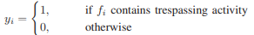[1]

5. Advantages: -

- A real-time ability can be gained to help avoid risks related to railway trespassing.
- Many such automated systems in the field can be integrated, including maintenance, security, traffic and passenger models, to form actions that consider multiple aspects.
- Improvements and experience can be integrated into the future learning process and automated effectively via machine learning, which is critical for safety systems.
- The effectiveness of safety operations in stations and other areas linked to railway activities can be improved.
- Time and costs can be saved while improving accuracy to enable long-term quality improvements.
- Both passenger and workforce experiences can be improved, which reflect on the overall market image.
- Data gathering can be enhanced to more fully utilise effective connections between assets and people.
- With the help of this system the delay in railway can be avoided caused by deaths on tracks.
- It helps in establishing a better crowd management trespassing detection system.

6. Disadvantages: -

- Some issues might occur in the future due to the large volume of data which affects the flow and speed of detecting desired outcomes.
- Installation and maintenance of this system at a large scale is expensive.
- Effectiveness of a Public Security Camera Is Doubted sometimes

7. Conclusion: -

This report explains the approach made into railway trespassing detection with a system that is capable of of executing security check with deep learning models to verify any trespassing breach and as an end result the model will generate alert signals to classify the trespassers in order to avoid any deaths. The accuracy of this model stands at 90-95% in detecting trespassing activities. This detection is totally based on frames that is created by the algorithm to detect human where the frames themselves are independent. With this approach we can gather information on trespassing activities and find and build effective solutions to avoid future trespassing activities.

8. ACKNOWLEDGEMENT: -

This paper along with the proposed solution would not have been possible with just a few people. To publish a research paper and to express your way understanding a problem and trying to come with a solution was inspired and was supported by a lot of people. We would like to express our sincere gratitude, deepest vote of thanks to our Project Guide Professor Mangesh Manake, without his constant support and guidance throughout the semester this project could not have been possible. Finally, we would like to extend our heartfelt gratitude to our friends and family members.

9. REFERENCES: -

- Muzammil Bashir, Elke A. Rundensteiner, Ramoza Ahsan, “A deep learning approach to trespassing detection using video surveillance data,” 2019 IEEE International Conference on Big Data(Big Data)
- Analytics Vidya , “A Practical Guide to Object Detection using the Popular YOLO Framework – Part III (with Python codes)”, Available: https://www.analyticsvidhya.com/blog/2018/12/practical-guide-object-detection-yolo-framewor-python/.
- Hamad Alawad , Sakdirat Kaewunruen , Min An, “A deep learning approach towards railway safety risk assessment” , 2020 IEEE Access.
- Huy Hoang Nguyen, Thi Nhung Ta, Ngoc Cuong Nguyen, Van Truong Bui, Hung Manh Pham, Duc Minh Nguyen, “YOLO based Real-Time Human detection for smart video surveillance at the edge”, 2021 IEEE Eighth International Conference on Communication & Electronics.
- Mohit Pandiya, Sayonee Dassani, Dr. Mangalraj P, “Analysis of Deep learning architectures for object detection – A critical review”, 2020, IEEE – HYDCON
- Guangli Wu*, Zhenzhou Guo, Leiting Li, Chengxiang Wang, “Video Abnormal Event detection based on CNN and LSTM”, 2020, IEEE 5th Internatinal conference on Signal and image processing.

BIOGRAPHIES :

 | Student, Dept of Computer Engineering, D.Y. Patil Institute of Engineering & Technology, Maharashtra, India.  Interests: Data Science, Machine Learning, Deep learning, Computer vision.
 | Student, Dept of Computer Engineering, D.Y. Patil Institute of Engineering & Technology, Maharashtra, India.  Interests: Data Science, Machine Learning, Deep learning – Computer vision, Cloud architect.
 | Student, Dept of Computer Engineering, D.Y. Patil Institute of Engineering & Technology, Maharashtra, India.  Interests: Data Science, Machine Learning, Deep learning.

